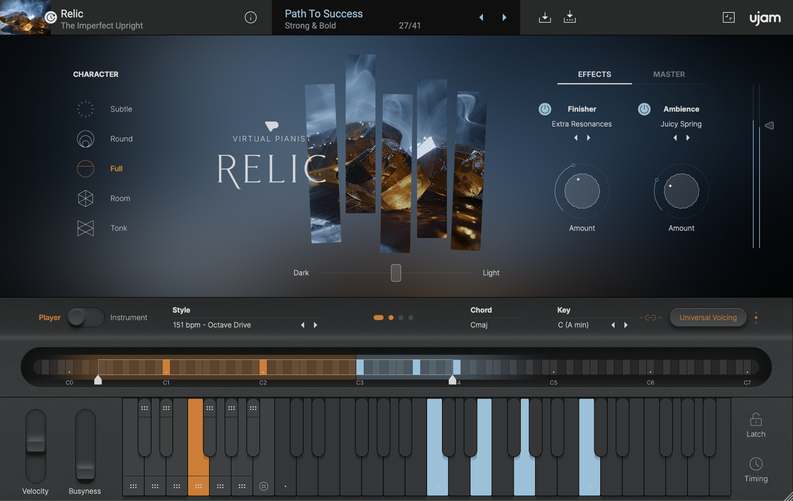

# UJAM Introduces Virtual Pianist RELIC, a Modern Take on the Classic Upright

*The innovative virtual instrument company, co-founded by Hans Zimmer, announces its newest music software designed for today’s digital production workflow. Virtual Pianist RELIC is now available to explore.*

**Berlin, Germany, July 24, 2024 —** Making musical instruments approachable and accessible for all is UJAM’s mission. The German-based company has reached artists worldwide with its collection of full-featured plug-ins that cover emulations of percussion, guitar, bass, piano, synthesizer, and more.

With today’s unveiling of [Virtual Pianist RELIC](http://ujam.com/pianist/relic/), UJAM invites contemporary music makers to add the sound and character of a traditional upright piano to their digital productions with ease.

Available in VST 2, VST 3, AU 2, and AAX formats, Virtual Pianist RELIC is compatible with a variety of DAWs.

## About RELIC: A Creative Companion for Any Musician

Virtual Pianist RELIC is based on the sound, playability, and character of a vintage, imperfect upright piano. It is perfect for song accompaniments and lyrical rhythm elements in a band arrangement — in styles ranging from John Lennon (Imagine) to Tom Waits, from Coldplay to Rihanna.

The acoustic upright piano has been used for centuries across genres and musical applications. Today, it is often heard in indie, singer-songwriter, pop, rock, and ambient works. RELIC makes it easy to apply the tone and mood of a traditional upright piano throughout any modern digital music production workflow.

**Key Features of Virtual Pianist RELIC:**

* Five characteristics from Subtle to Full to Tonk
* 30 styles, over 180 complex phrases
* One- and two-handed accompaniment, arpeggios, chords, runs, low chords, and fills
* Dynamic ‘busyness’ control creates additional rhythmic elements
* Three voicing modes (simple, universal, complex) with different harmonic complexities
* 30 Finisher effects, 30 ambiences (delay and reverb programs)

## A Look Inside the Development Process

Every product innovation has a story — a response to need, want, or request in the market. When it comes to the world of music software, UJAM’s commitment to making instruments accessible to creatives with or without musical experience sets the company and its offerings apart.

UJAM’s co-founder Peter Gorges, an accomplished electronic musician and sound designer, speaks to RELIC’s development and the “why” behind the Virtual Pianist collection:

“First off, our team selected a beautiful, well-burnt-in upright piano and kept it in our studio for months. Weeks went by just tweaking the tuning, playing with microphone setups and other things until everyone was happy. Only then it was meticulously recorded and added into the Virtual Pianist instrument framework.

There’s a reason why Virtual Pianist isn’t called Virtual Piano, and that is the sophisticated built-in Player, which is at least as important as the piano itself. Our style and piano expert Derek von Krogh created a signature collection of bespoke style performances for RELIC, as he's done with every Virtual Pianist before. The moment we married the piano and the pianist was a true revelation, as both elements just clicked together beautifully — you’ll be able to experience that in every phrase, in every preset.”

## More about UJAM’s Virtual Pianist Series

Based on professional piano models for every musical genre, UJAM now offers four completely unique Virtual Pianist options:

* Virtual Pianist VOGUE: Session pianist, acoustic grand piano for pop and rock
* Virtual Pianist SCORE: Cinematic pianist, classical grand piano for big emotions
* Virtual Pianist VIBE: Jazz keyboardist, electric piano for soul to hip hop
* Virtual Pianist RELIC: A wide range of sounds and musical styles, from electric piano to grand piano, from pop and rock to soul and RnB, from film scores to ambient tracks

**Key Features of the Virtual Pianist Series:**

* Standardized operation, easy to learn, requires no keyboard skills
* Let the piano play for you or play yourself — simply select instrument mode or player mode
* Integrated player engine — a built-in pianist that produces realistic accompaniments with a total of over 2000 phrases, adjustable in terms of harmony, style, and dynamics
* Play the piano yourself using instrument mode
* Authentic piano voicings and harmonization guaranteed
* Professional piano libraries with extensive sound customization options
* Numerous multi-effects for creative sound design
* Piano, recording technology, playing techniques, styles, phrases, effects – everything is individually optimized for every pianist
* Drag & drop — all styles can be exported as MIDI, edited and exchanged between pianists
* Easy installation and license management with the UJAM app
* ‘Frustration-free’ operation guaranteed — ‘incorrect’ settings are not possible

For more information about Virtual Pianist RELIC and to download the instrument, [click here](http://ujam.com/pianist/relic/).

**About UJAM**

UJAM was co-founded by Hans Zimmer and Pharrell Williams, both musicians whose careers have been significantly supported by technology. The vision behind UJAM is to make technology even more accessible and encourage even more people to make music.

This vision is being realized by a team of virtual instrument pioneers who had previously developed legendary virtual instruments from Steinberg and Digidesign — from Steinberg Hypersonic to Virtual Guitarist, from Digidesign Xpand to Transfuser — and who finally want to realize their vision of shortening the path from the idea to the perfect track. More fun, better results, less complexity.